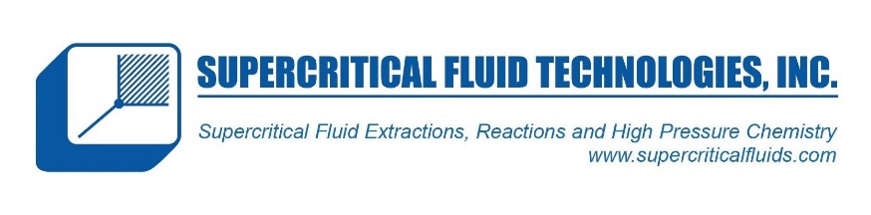
CP Reciprocating Pump

Constant Pressure Dual Head Pumps

The high performance CP Class consists of dual-headed, positive displacement piston pumps with constant pressure control, covering a wide range of flows, with pressures up to 25,000 psi. Standard fluid path materials are Stainless Steel, with optional Titanium and Hastelloy also available. Other optional features include jacketed pump heads for temperature-controlled applications.
The CP Class pumps are widely used for LC Column packing, as well as many process applications. The constant-pressure feedback loop automatically adjusts solvent flow to maintain constant system pressure and allows the user to select a wide range of process parameters, including desired pressure set point, ramp rate, and upper flow rate limit.
The CP Class is available as standalone units, and also with the SSI Column Packing System (called Pack-in-a-Box). Features include an integrated Prime-Purge Valve, interactive keypad control, advanced pressure control algorithms, and complete PC control and status through RS-232C, micro-USB, and Ethernet serial communications ports. With 5 mL/min, 12 mL/ min, 24 mL/min, and 100 mL/min versions, the CP Class will meet most LC Column packing and process needs.

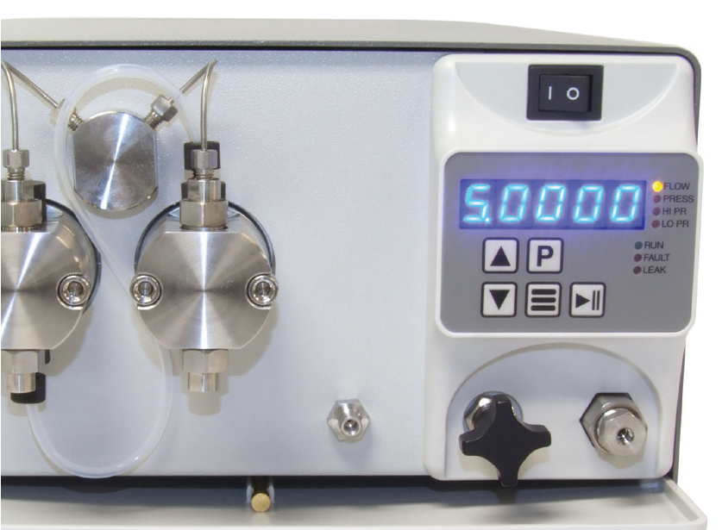
Enhanced Cosmetic Design
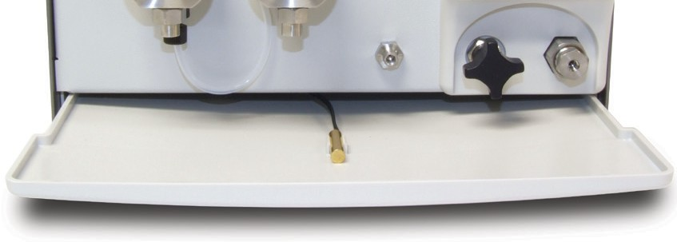
Drip Tray & Leak Sensor



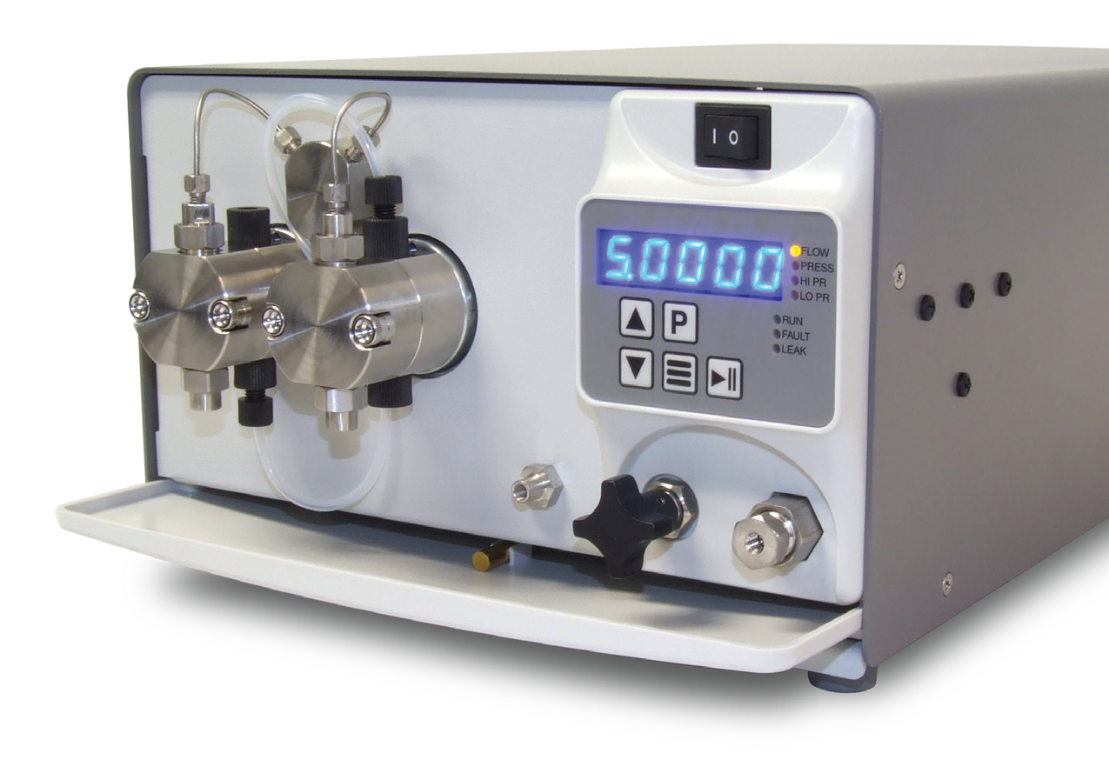


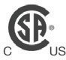

FLOW RATE
5 mL/min
12 mL/min
24 mL/min
100 mL/min
PRESSURE
Up to 25,000 psi (5 mL/min)
FLUID PATH
Stainless Steel, Titanium, or Hastelloy
CONTROL
RS-232, Micro USB,
Ethernet, Run/Stop,
Analog
(0-10 V, 4-20 mA)

CP Class Specifications

 | 5 mL/min | 12 mL/min | 24 mL/min | 100 mL/min
Flow Rate Range | 0.001 – 5.000 mL/min | 0.001 – 12.000 mL/min | 0.01 – 24.00 mL/min | 0.1 – 100.0 mL/min
Flow Rate Increment | 0.001 mL/min | 0.001 mL/min | 0.01 mL/min | 0.1 mL/min
Pressure Accuracy | ±2% of full-scale pressure
Pressure Control Accuracy | Dependent on hydraulic system parameters. Pump automatically adjusts fluid flow to maintain constant system pressure under typical column-packing usage. Pump does not contain an automatic pressure-relief valve.
Maximum Delivery Pressure | 25,000 psi | 18,000 psi | 10,000 psi | 4,000 psi
Piston Displacement | 15.0 µL | 31.4 µL | 62.8 µL | 251 µL
Piston Wash | Includes option for self-flushing pump heads—continuous wash without auxiliary pump
Wetted Materials | Stainless Steel pumps may include: Incoloy A-286, 316 Stainless Steel, Silicon Carbide, Synthetic Ruby, Sapphire, Zirconia, ATZ, UHMWPE, PEEK, FFKM, PFA, PTFE, ETFE  Hastelloy pumps: Hastelloy C-276, Synthetic Ruby, Sapphire, UHMWPE, FFKM, PFA, PTFE, ETFE
Dimensions (H x W x D) | 6.4” x 9.9” x 17.5” (16.3 x 25.1 x 44.5 cm) (Jacketed Hastelloy heads add 0.7” (1.7 cm) to length of pump)
Weight | 30 lbs (13.6 kg)
Power | 100 – 240 VAC (±10%), 50 – 60 Hz, 75 W
Front Panel | 5-digit LED to monitor flow rate, pressure, and indicate parameters and alarms. Run/Stop, Prime, and menu keys, seven status indicators, Increase/Decrease displayed parameters.
Communication | RS-232, micro-USB, LAN (serial communications) Run/Stop TTL, Analog flow control (0–10 V, 4–20 mA)
Viscosity* | 0.5 – 10.8 cP
Liquid Temperature | 0 – 82 °C
Environment | Indoor use only (Pollution degree 2)
Altitude | Up to 2000 m (6500 ft)
Ambient Temperature | 10 – 30 °C
Humidity | 20 – 90% relative humidity
CSA Certification | Compliant to UL Std 61010-1 3rd Edition and CSA Safety Standard 61010-1-12, Class 8721-06 and 8721-86 (5 mL and 12 mL models not included)
*Range of fluid viscosities where published pressure accuracy is maintained

One Innovation Way • Newark, DE 19711 • 302-738-3420 • Fax 302-738-4320 • www.supercriticalfluids.com

