




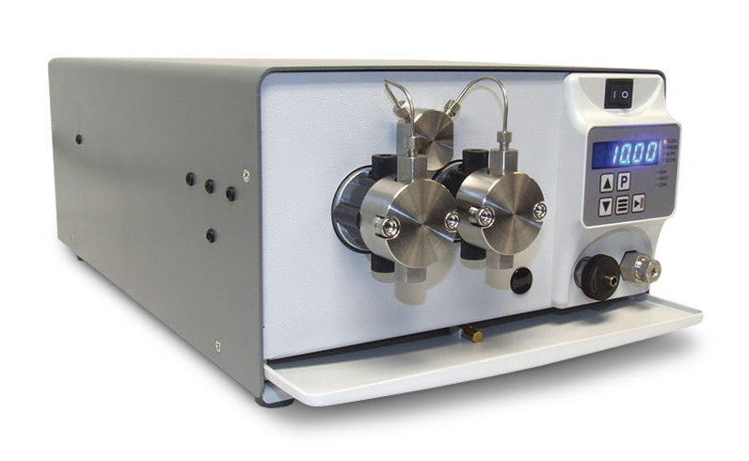


LD Reciprocating Pump

Dual Piston Pumps for Low Pulsation Requirements
The versatile LD Class consists of dual-headed, positive displacement piston pumps, delivering unmatched performance for analytical,
flash, and small-scale preparative chromatography applications. With the patented SSI low dead-volume Pulse Dampener, advanced cam technology and dual piston mechanism, the LD Class provides virtually pulse-free operation.
The pumps are designed for high flow rate accuracy and low pulsation required for Analytical Liquid Chromatography (HPLC). Standard fluid path materials are Stainless Steel and PEEK, with optional Titanium and Hastelloy also available. Other optional features include jacketed pump heads for temperature-controlled applications. With 12 mL/min, 36 mL/min, and 100 mL/min versions, reaching pressures up to 6,000 psi, these pumps will meet the performance requirements of demanding HPLC needs.
The high performance linear cams, along with automatic pressure compensation, provide precise flow rates for very accurate high pressure and low pressure gradients. Standard features include an integrated Prime-Purge Valve, Pulse Dampener, interactive keypad control, and complete PC control and status through RS-232C, micro- USB, and Ethernet serial communications. The LD Class provides the precise flow and low pulsation for the most challenging separations.

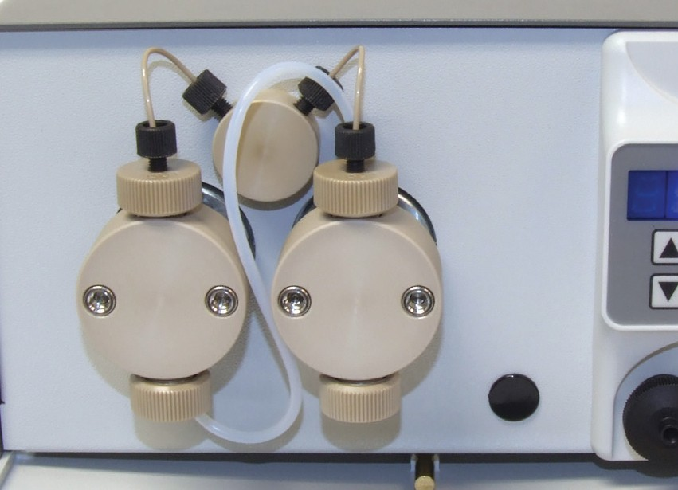
Several Fluid Path Materials Available
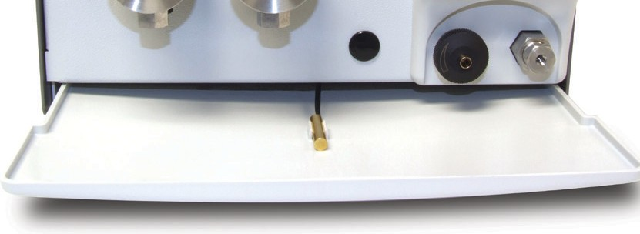
Drip Tray & Leak Sensor

FLOW RATE
12 mL/min
36 mL/min
100 mL/min
PRESSURE
Up to 6,000 psi
(12 or 36 mL/min)
FLUID PATH
Stainless Steel, PEEK, Titanium, or Hastelloy
CONTROL
RS-232, Micro USB,
Ethernet, Run/Stop,
Analog
(0-10 V, 4-20 mA)

LD Class Specifications

 | 12 mL/min | 36 mL/min | 100 mL/min
Flow Rate Range | 0.001 – 12.000 mL/min | 0.01 – 36.00 mL/min | 0.1 – 100.0 mL/min
Flow Rate Increment | 0.001 mL/min | 0.01 mL/min | 0.1 mL/min
Flow Rate Accuracy* | ±2% (1.000 – 12.000 mL/min;  80:20 Water/IPA; 1,000 psi) | ±2% (2.00 – 32.00 mL/min;  80:20 Water/IPA; 1,000 psi) | ±2% (0.5 – 100.0 mL/min;  80:20 Water/IPA; 500 psi)
Flow Reproducibility | 0.5% RSD (1.000 – 12.000 mL/min;  80:20 Water/IPA; 1,000 psi) | 0.5% RSD (1.00 – 36.00 mL/min;  80:20 Water/IPA; 1,000 psi) | 0.5% RSD (1.0 – 100.0 mL/min;  80:20 Water/IPA; 500 psi)
Maximum Delivery Pressure | 5,000 psi (PEEK)  6,000 psi (Stainless Steel, Titanium, and Hastelloy) | 5,000 psi (PEEK)  6,000 psi (Stainless Steel, Titanium, and Hastelloy) | 1,500 psi
Pressure Accuracy | ±50 psi |  | ±12.5 psi
Pulsation | ≤2% @ 1 mL/min and 80:20 Water/IPA; 1,000 psi | ≤1.0% @ 4 mL/min and 80:20 Water/IPA; 1,000 psi | ≤2.0% @ 50 mL/min and 80:20 Water/IPA; 250 psi
Piston Displacement | 30.0 µL | 62.8 µL | 251 µL
Piston Wash | Self-flushing pump heads – continuous wash without auxiliary pump
Wetted Materials | PEEK pumps may include: PEEK, Synthetic Ruby, Sapphire, Zirconia, UHMWPE, FFKM, PFA, ETFE Stainless Steel pumps may include: 316 Stainless Steel, PEEK, Synthetic Ruby, Sapphire, Zirconia, UHMWPE, PFA, PTFE, ETFE  Hastelloy pumps may include: Hastelloy C-276, Synthetic Ruby, Sapphire, Zirconia, UHMWPE, FFKM, PFA, PTFE, ETFE
Dimensions (H x W x D) | 6.4” x 9.9” x 17.5” (16.3 x 25.1 x 44.5 cm) (Jacketed Hastelloy heads add 0.7” (1.7 cm) to length of pump)
Weight | 21.4 lbs (9.7 kg)
Power | 100 – 240 VAC (±10%), 50 – 60 Hz, 75 W
Front Panel | 5-digit LED to monitor flow rate, pressure, and indicate parameters and alarms. Run/Stop, Prime, and menu keys, seven status indicators, Increase/Decrease displayed parameters.
Communication | RS-232, micro-USB, LAN (serial communications) Run/Stop TTL, Analog flow control (0–10 V, 4–20 mA)
Viscosity** | 0.5 – 10.8 cP | 0.5 – 10.8 cP | 0.5 – 10.8 cP
Liquid Temperature | 0 – 82 °C
Environment | Indoor use only (Pollution degree 2)
Altitude | Up to 2000 m (6500 ft)
Ambient Temperature | 10 – 30 °C
*Flow Rate is dependent on solvent selection and operating pressure
**Range of fluid viscosities where published flow accuracy is maintained

One Innovation Way • Newark, DE 19711 • 302-738-3420 • Fax 302-738-4320 • www.supercriticalfluids.com

