


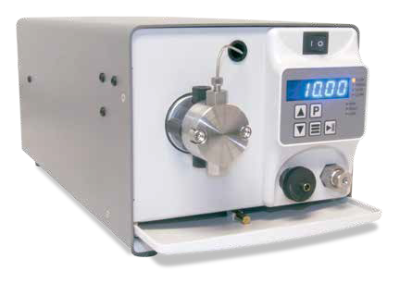
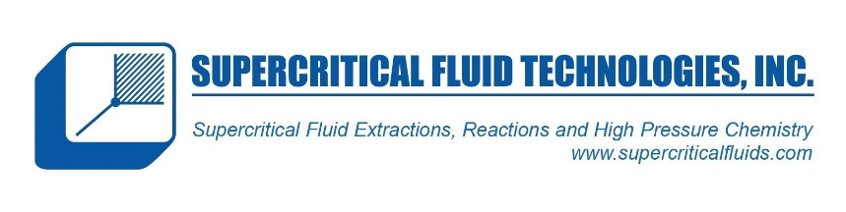
LS Reciprocating Pump

High Performance Isocratic Pumps

The reliable LS Class consists of single-headed, positive displacement piston pumps incorporating advanced cam designs for very low pulsation. With micro-stepping motor technology and a proven single-piston pump mechanism, the LS Class exceeds the performance of more expensive units at a fraction of the cost.
The pumps are ideal for a wide variety of HPLC applications (including Bio-compatible separations), Semi-Prep LC, metering & dispensing, and general laboratory use.
Standard fluid path materials are Stainless Steel and PEEK, with optional Titanium and Hastelloy also available. Other optional features include jacketed pump heads for temperature-controlled applications. With 5 mL/min, 10 mL/min and 40 mL/min versions available, and pressure capability up to 6,000 psi, these versatile pumps will meet the most demanding applications.
Features include automatic pressure compensation, Pulse Dampener, integrated Prime-Purge Valve, interactive keypad control, and complete PC control and status through RS- 232C, micro-USB, and Ethernet serial communications. The unique LS Class provides the highest performance/cost ratio in a compact package.

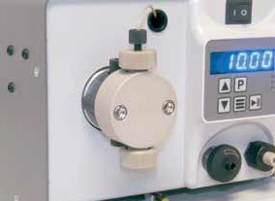
Several Fluid Path Materials Available
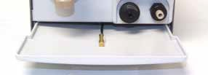
Drip Tray & Leak Sensor

FLOW RATE
5 mL/min
10 mL/min
40 mL/min

PRESSURE
Up to 6,000 psi
(5 mL/min or 10 mL/min)

FLUID PATH
Stainless Steel, PEEK, Titanium, or Hastelloy

CONTROL
RS-232, Micro USB,
Ethernet, Run/Stop,
Analog
(0-10 V, 4-20 mA)

LS Class Specifications

 | 5 mL/min | 10 mL/min | 40 mL/min
Flow Rate Range | 0.001 – 5.000 mL/min | 0.01 – 10.00 mL/min | 0.1 – 40.0 mL/min
Flow Rate Increment | 0.001 mL/min | 0.01 mL/min | 0.1 mL/min
Flow Rate Accuracy* | ±2% (0.500 – 5.000 mL/min;  80:20 Water/IPA; 1,000 psi) | ±2% (1.00 – 10.00 mL/min;  80:20 Water/IPA; 1,000 psi) | ±2% (4.0 – 40.0 mL/min;  80:20 Water/IPA; 1,000 psi)
Flow Reproducibility | 1% RSD (0.500 – 5.000 mL/min;  80:20 Water/IPA; 1,000 psi) | 1% RSD (1.00 – 10.00 mL/min;  80:20 Water/IPA; 1,000 psi) | 1% RSD (0.5 – 40.0 mL/min;  80:20 Water/IPA; 1,000 psi)
Maximum Delivery Pressure | 5,000 psi (PEEK)  6,000 psi (Stainless Steel, Titanium, and Hastelloy) | 5,000 psi (PEEK)  6,000 psi (Stainless Steel, Titanium, and Hastelloy) | 1,500 psi
Pressure Accuracy | ±50 psi
Pulsation | ≤2.0% @ 1 mL/min and  80:20 Water/IPA; 1,000 psi | ≤3.0% @ 1 mL/min and  80:20 Water/IPA; 1,000 psi | ≤4.0% @ 4 mL/min and  80:20 Water/IPA; 1,000 psi
Piston Displacement | 25.1 µL | 50.3 µL | 201 µL
Piston Wash | Self-flushing pump heads – continuous wash without auxiliary pump
Wetted Materials | PEEK pumps may include: PEEK, Synthetic Ruby, Sapphire, Zirconia, UHMWPE, FFKM, PFA, ETFE  Stainless Steel pumps may include: 316 Stainless Steel, PEEK, Synthetic Ruby, Sapphire, Zirconia, UHMWPE, PFA, PTFE, ETFE  Hastelloy pumps may include: Hastelloy C-276, Synthetic Ruby, Sapphire, Zirconia, UHMWPE, FFKM,PFA, PTFE, ETFE
Dimensions (H x W x D) | 6.4” x 7.0” x 16.0” (16.3 x 17.8 x 40.6 cm)
Weight | 15.5 lbs (7.0 kg)
Power | 100 – 240 VAC (±10%), 50 – 60 Hz, 45 W
Front Panel | 5-digit LED to monitor flow rate, pressure, and indicate parameters and alarms. Run/Stop, Prime, and menu keys, seven status indicators, Increase/Decrease displayed parameters.
Communication | RS-232, micro-USB, LAN (serial communications) Run/Stop TTL, Analog flow control (0 –10 V, 4 –20 mA)
Viscosity** | 0.5 – 3.0 cP | 0.5 – 5.0 cP | 0.5 – 9.4 cP
Liquid Temperature | 0 – 82 °C
Environment | Indoor use only (Pollution degree 2)
Altitude | Up to 2000 m (6500 ft)
Ambient Temperature | 10 – 30 °C
Humidity | 20 – 90% relative humidity
*Flow Rate is dependent on solvent selection and operating pressure
**Range of fluid viscosities where published flow accuracy is maintained

One Innovation Way • Newark, DE 19711 • 302-738-3420 • Fax 302-738-4320 • www.supercriticalfluids.com

