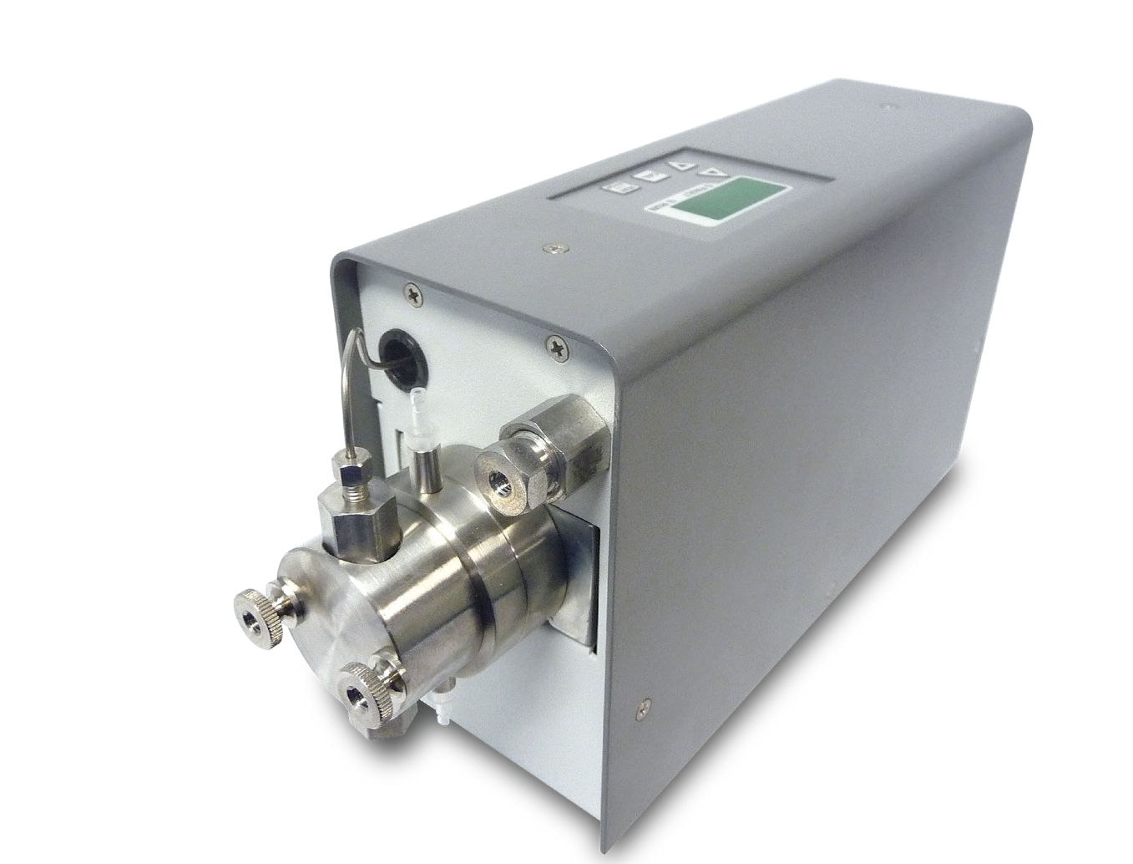

Single Piston Pumps

with Excellent Capability at a Low Cost
The compact M1 Class consists of single-headed, positive displacement piston pumps that deliver high-performance and precision at an affordable price. Superior to Gear, Diaphragm, and Peristaltic pumps, the M1Class provides greater performance at an equivalent cost to lesser- functioning products.
Applications include precise chemical metering, dispensing, and specific HPLC separations. Standard fluid path materials are Stainless Steel and PEEK. With 10 mL/min, 40 mL/min, and 100 mL/min versions, reaching pressures up to 2,500 psi, these pumps capture the majority of typical laboratory fluid transfer applications.
Features include interactive keypad control, Outlet Filter,
RS-232 Serial and Micro USB 2.0 ports for complete PC control and status, as well as hardware for laboratory stand mounting. Having the smallest possible footprint for a high pressure pump, the M1 Class will easily integrate into any laboratory or industrial environment.



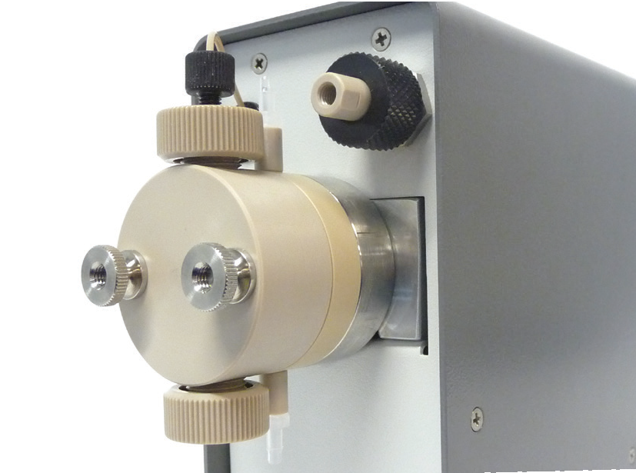
Stainless Steel & PEEK Fluid Path Material Available





M1 Reciprocating Pump

FLOW RATE
10 mL/min
40 mL/min
100 mL/min
PRESSURE
Up to 2,500 psi
(10 mL/min)
FLUID PATH
Stainless Steel, or PEEK
CONTROL
RS-232, Micro USB,
Run/Stop

M1 Class Specifications

 | 10 mL/min | 40 mL/min | 100 mL/min
Flow Rate Range | 0.01 – 10.00 mL/min | 0.1 – 40.0 mL/min | 0.1 – 100.0 mL/min
Flow Rate Increment | 0.01 mL/min | 0.1 mL/min | 0.1 mL/min
Flow Rate Accuracy* | ±5% (0.5 – 10.0 mL/min;  80:20 Water/IPA; 1,000 psi) | ±5% (1.0 – 36.0 mL/min;  80:20 Water/IPA; 250 psi) | ±5% (10.0 – 100.0 mL/min;  80:20 Water/IPA; 100 psi)
Flow Reproducibility | 1.5% RSD (0.3 – 10.0 mL/min;  80:20 Water/IPA; 1,000 psi) | 1% RSD (1.0 – 36.0 mL/min;  80:20 Water/IPA; 250 psi) | 1% RSD (2.0 – 100.0 mL/min;  80:20 Water/IPA; 100 psi)
Maximum Delivery Pressure | 2,500 psi | 500 psi | 250 psi
Pressure Accuracy | N/A
Piston Displacement | 25.1 µL | 100 µL | 226 µL
Piston Wash | Self-flushing pump heads – continuous wash without auxiliary pump |  | N/A
Wetted Materials | PEEK pumps may include: PEEK, Synthetic Ruby, Sapphire, UHMWPE, FFKM  Stainless Steel pumps may include: 316 Stainless Steel, PEEK, Synthetic Ruby, Sapphire, Alumina, UHMWPE, PTFE, ETFE
Dimensions (H x W x D) | 5.6” x 3.0” x 10.6” (14.2 x 7.6 x 26.9 cm)
Weight | 6 lbs (2.7 kg)
Power | 100 – 240 VAC (±10%), 50 – 60 Hz, 40 W
Front Panel | 4-digit LED to monitor flow rate and indicate alarms. Run/Stop and menu keys, two status indicators, Increase/Decrease displayed parameters.
Communication | RS-232, micro-USB, Run/Stop TTL
Viscosity** | 0.5 – 7.0 cP | 0.5 – 5.2 cP | 0.5 – 6.0 cP
Liquid Temperature | 0 – 82 °C
Environment | Indoor use only (Pollution degree 2)
Altitude | Up to 2000 m (6500 ft)
Ambient Temperature | 10 – 30 °C
Humidity | 20 – 90% relative humidity
*Flow Rate is dependent on solvent selection and operating pressure
**Range of fluid viscosities where published flow accuracy is maintained

One Innovation Way • Newark, DE 19711 • 302-738-3420 • Fax 302-738-4320 • www.supercriticalfluids.com

