
MX Reciprocating Pump

High Performance Isocratic Pumps at
an Affordable Price
The economical MX Class consists of single-headed, positive displacement piston pumps incorporating additional features for challenging applications. With pressure capability up to 5,000 psi, the MX Class can be used in both analytical and small-scale preparative HPLC separations.
Further applications include demanding metering and dispensing, as well as Sample Injection, Infusion, or Cone Wash for Mass Spectrometers. Standard fluid path materials are Stainless Steel and PEEK.
Features include pressure monitoring with automatic pressure compensation, Pulse Dampener, integrated Prime-Purge Valve, interactive keypad control, and complete PC control and status through RS-232C, micro-USB, and Ethernet serial communications. Requiring minimal bench space for the performance, the MX Class will easily integrate into most workspaces.



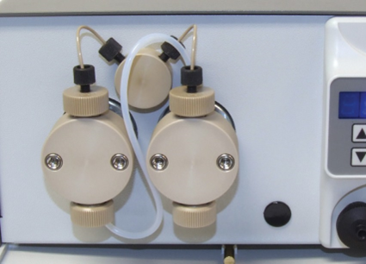
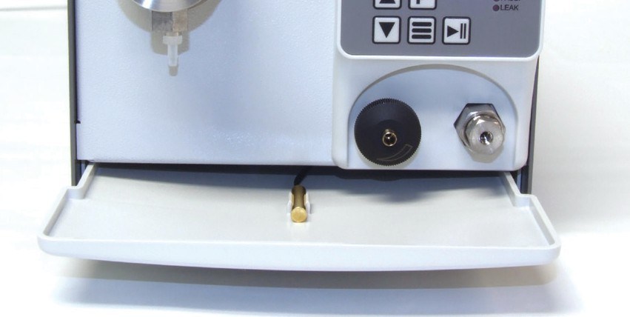
Several Fluid Path Materials Available
Drip Tray & Leak Sensor




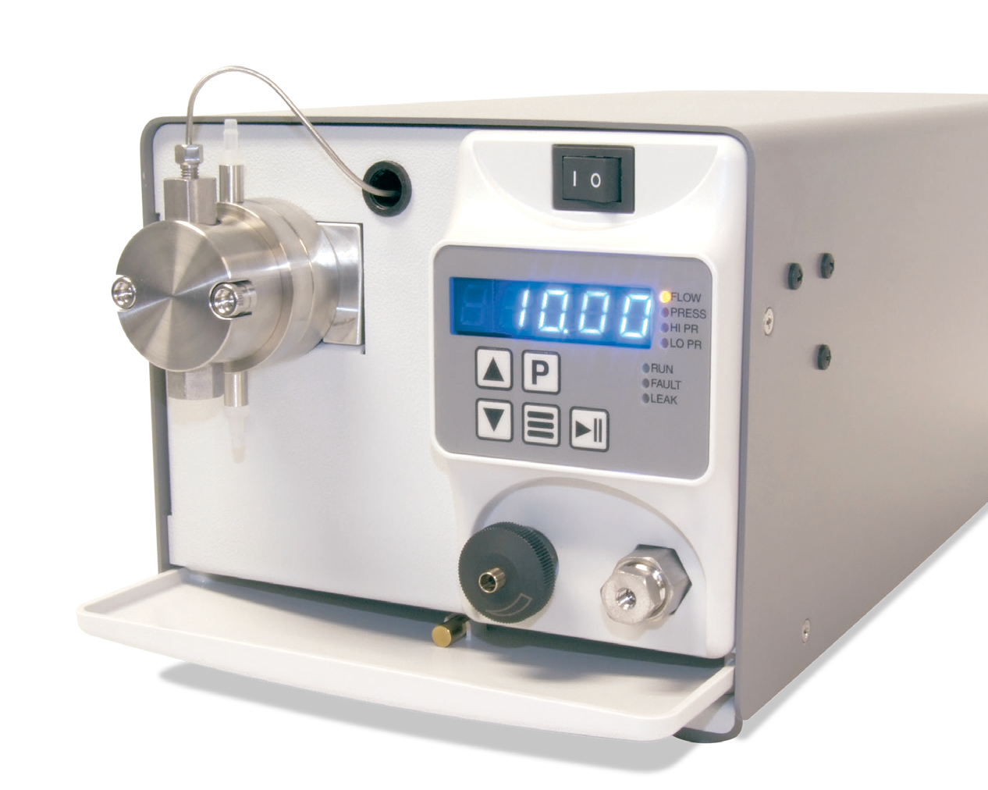

FLOW RATE
10 mL/min
PRESSURE
5,000 psi
FLUID PATH
Stainless Steel, or PEEK
CONTROL
RS-232, Micro USB,
Ethernet, Run/Stop,
Analog
(0-10 V, 4-20 mA)

MX Class Specifications

Flow Rate Range | 0.01 – 10.00 mL/min | 0.1 – 40.0 mL/min
Flow Rate Increment | 0.01 mL/min | 0.1 mL/min
Flow Rate Accuracy* | ±2% (1.5 – 10.0 mL/min; 80:20 Water/IPA; 1,000 psi) | ±5% (0.8 – 40.0 mL/min; 80:20 Water/IPA; 100 psi)
Flow Reproducibility | 1.0% RSD (1.5 – 10 mL/min; 80:20 Water/IPA; 1,000 psi) | 1.0% RSD (1.5 – 10 mL/min; 80:20 Water/IPA; 1,000 psi)
Maximum Delivery Pres- sure | 5,000 psi | 900 psi
Pressure Accuracy | ±50 psi | ±50psi
Pulsation | ≤3.0% @ 1 mL/min and 80:20 Water/IPA; 1,000 psi | ≤5.0% @ 4 mL/min and 80:20 Water/IPA; 250 psi
Piston Displacement | 25.1 µL | 100.5 µL
Piston Wash | Self-flushing pump heads – continuous wash without auxiliary pump
Wetted Materials | PEEK pumps may include: PEEK, Synthetic Ruby, Sapphire, UHMWPE, FFKM, PFA, ETFE  Stainless Steel pumps may include: 316 Stainless Steel, Synthetic Ruby, Sapphire, UHMWPE, PTFE, ETFE, PFA, PEEK
Dimensions (H x W x D) | 6.4” x 7.0” x 16.0” (16.1 x 17.8 x 40.6 cm)
Weight | 14.2 lbs (6.4 kg)
Power | 100 – 240 Vac (±10%), 50-60 Hz, 45 W
Front Panel | 5-digit LED to monitor flow rate, pressure, and indicate parameters and alarms. Run/Stop, Prime, and menu keys, seven status indicators, Increase/Decrease displayed parameters.
Communication | RS-232, micro-USB, LAN (serial communications) Run/Stop TTL, Analog flow control (0-10V, 4-20 mA)
Viscosity** | 0.5 – 3.5 cP
Liquid Temperature | 0 – 82 °C
Environment | Indoor use only (Pollution degree 2)
Altitude | Up to 2000 m (6500 ft)
Ambient Temperature | 10 - 30°C
Humidity | 20 – 90% relative humidity
*Flow Rate is dependent on solvent selection and operating pressure
**Range of fluid viscosities where published flow accuracy is maintained

One Innovation Way • Newark, DE 19711 • 302-738-3420 • Fax 302-738-4320 • www.supercriticalfluids.com

.

