

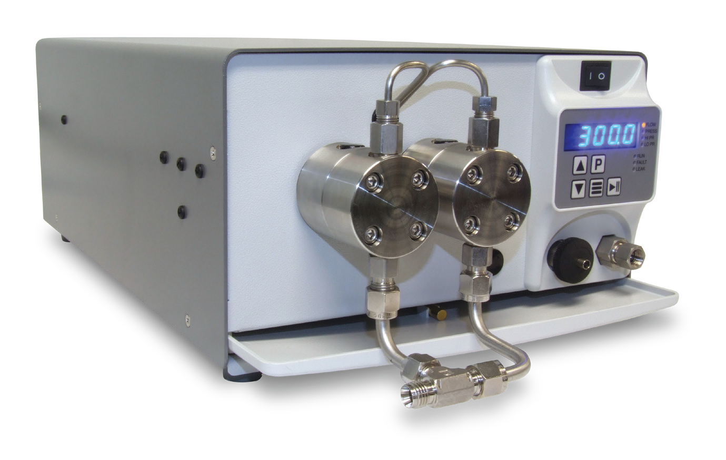


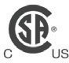

PR Reciprocating Pump

High-Flow Dual Head Pumps

The rugged PR Class consists of dual-headed, positive displacement piston pumps that provide high, accurate flows and excellent pressure capability for a variety of uses.
Standard fluid path materials are Stainless Steel and PEEK, with optional Titanium and Hastelloy also available. Other optional features include jacketed pump heads for temperature-controlled applications.
The pumps are designed for a wide range of Preparative and Semi-Prep Chromatography, as well as SMBC (simulated
moving bed chromatography), and many process and
industrial applications. With 100 mL/min and 300 mL/min versions, reaching pressures up to 4,000 psi, the pumps will meet the most demanding LC and process needs.
Features include an integrated Prime-Purge Valve, interactive keypad control, and complete PC control and status through RS-232C, micro-USB, and Ethernet serial communications. The PR Class provides the flow rates and pressures required for high throughput separations.

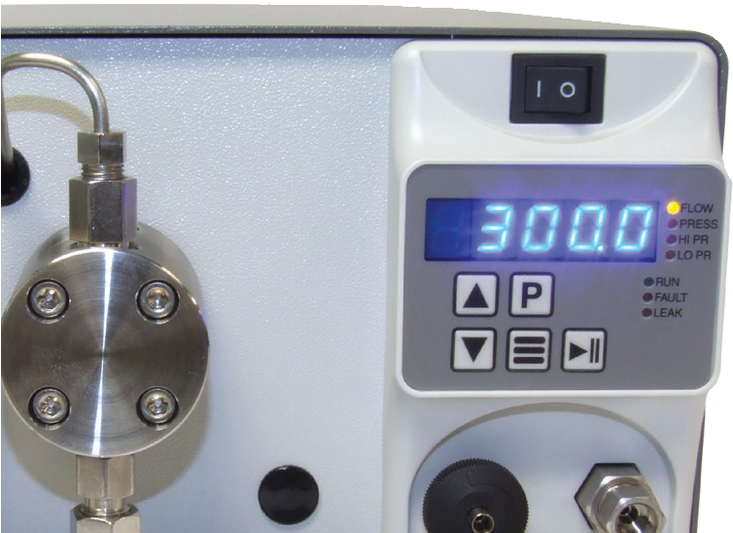
Enhanced Cosmetic Design
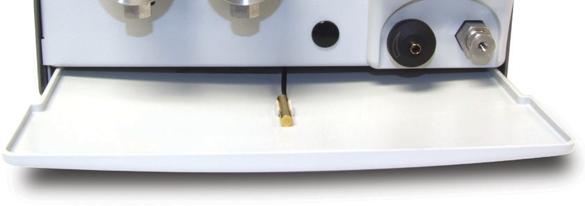
Drip Tray & Leak Sensor

FLOW RATE
100 mL/min
300 mL/min

PRESSURE
Up to 4,000 psi (100 mL/min)

FLUID PATH
Stainless Steel, PEEK, Titanium, or Hastelloy

CONTROL
RS-232, Micro Usb, Ethernet, Run/Stop, Analog (0-10 V, 4-20 mA)

PR Class Specifications
 | 100 mL | 300 mL
Flow Rate Range | 0.0–100.0 mL/min | 0.0–300.0 mL/min
Flow Rate Increment | 0.1 mL/min | 0.1 mL/min
Flow Rate Accuracy* | ±3% (0.5 mL/min and above;  80:20 Water/IPA; 1,000 psi) | ±3% (1.5 mL/min and above;  80:20 Water/IPA; 500 psi)
Flow Reproducibility | 0.5% RSD (1.0 mL/min and above;  80:20 Water/IPA; 1000 psi) | 1% RSD (3.0 mL/min and above;  80:20 Water/IPA; 500 psi)
Maximum Delivery Pressure | 4,000 psi | 1,000 psi
Pressure Accuracy | All 100 mL pumps and PEEK 300 mL: ±50 psi  SS and Hastelloy 300 mL: ±12.5 psi
Pulsation | 100 mL pumps: ≤2.0% @ 10 mL/min and 1000 psi  300 mL SS and Hastelloy pumps: ≤2.0% @ 100 mL/min and 500 psi  300 mL PEEK pumps: ≤4.0% @ 100 mL/min and 500 psi
Piston Displacement | 251 µL | 565 µL
Piston Wash | Self-flushing pump heads—continuous wash without auxiliary pump
Wetted Materials | PEEK pumps may include: PEEK, Synthetic Ruby, Sapphire, Zirconia, Alumina, Titanium, UHMWPE, FKM, FFKM, PTFE, ETFE, PFA  Stainless Steel pumps may include: 316 Stainless Steel, PEEK, Synthetic Ruby, Sapphire, Zirconia, Alumina, UHMWPE, PTFE, ETFE, PFA  Hastelloy pumps may include: Hastelloy C-276, Synthetic Ruby, Sapphire, Zirconia, Alumina, UHMWPE, FKM, PTFE, ETFE, PFA
Dimensions (H x W x D) | 6.4” x 9.9” x 17.7” (16.1 x 25.1 x 45 cm) (Jacketed Hastelloy heads add 0.9” (2.1 cm) to length of pump)
Weight | 26.3 lbs (11.9 kg)
Power | 100– 240 VAC (±10%), 50– 60 Hz, 75 W
Front Panel | 5-digit LED to monitor flow rate, pressure, and indicate parameters and alarms. Run/Stop, Prime, and menu keys, seven status indicators, Increase/Decrease displayed parameters.
Communication | RS-232, micro-USB, LAN (serial communications) Run/Stop TTL, Analog flow control (0–10V, 4–20 mA)
Viscosity** | 0.5 –10.8 cP
Liquid Temperature | 0– 82 °C
Environment | Indoor use only (Pollution degree 2)
Altitude | Up to 2000 m
*Flow Rate is dependent on solvent selection and operating pressure
**Range of fluid viscosities where published flow accuracy is maintained

One Innovation Way • Newark, DE 19711 • 302-738-3420 • Fax 302-738-4320 • www.supercriticalfluids.com

